MY FATHER

My father name is MR. YOGESH KUMAR. My father is a good man. HE WORKS IN A MOTOR BIKE COMPANY NAMED HERO. HE LOVES ME SO MUCH AND CARES ME A LOT.

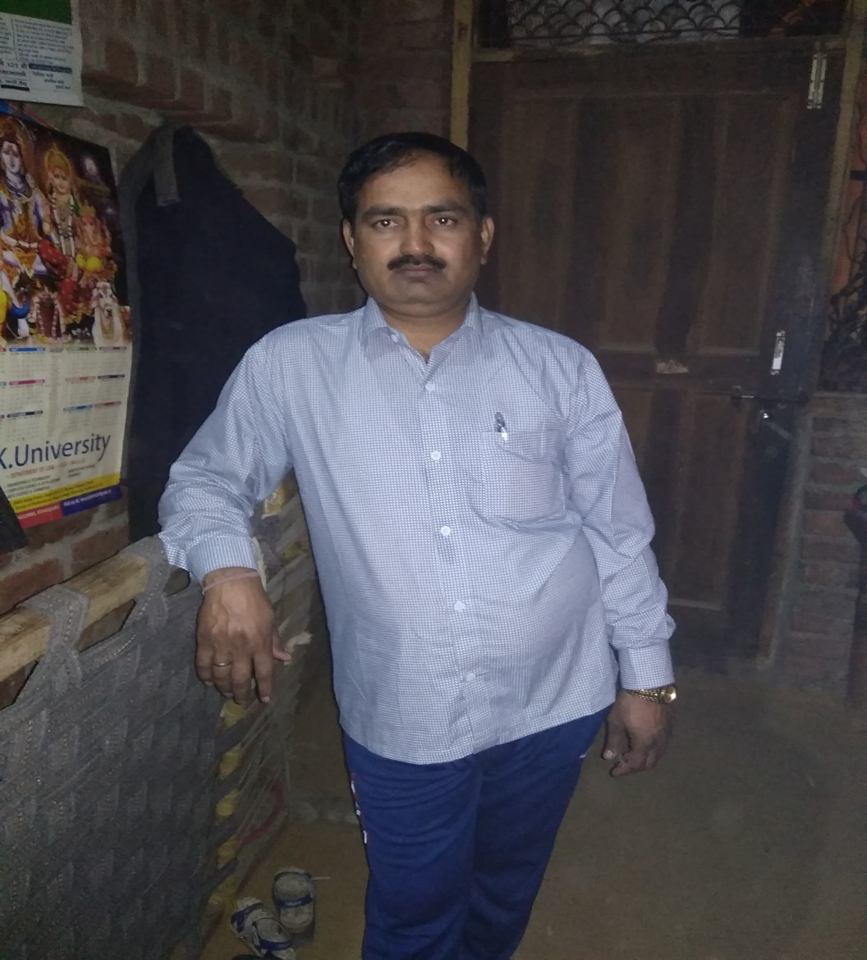

MY MOTHER

MY MOTHER NAME IS PRIYA. SHE IS VERY LOVELY AND ALSO VERY DANGEROUS. SHE LOVES ME VERY MUCH AND I ALSO LOVE HER VERY MUCH. SOMETIMES SHE BEATS ME VERY HARD BUT IT’S FINE.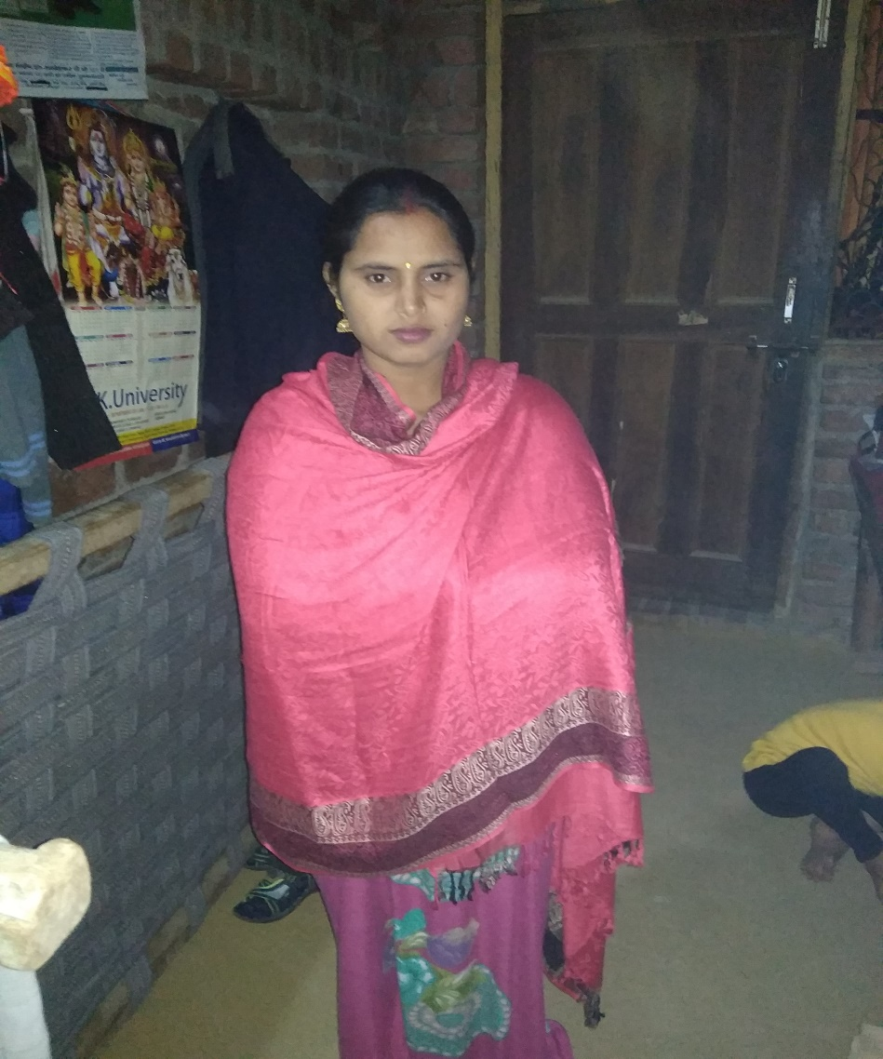

MY SISTER

MY SISTER NAME IS PAWANI. SHE IS VERY CUTE AND I LOVE HER VERY MUCH. SHE LOOKS LIKE A DOOL. SHE STUDIES IN 4TH CLASS AND SHE IS VERY INTELLEGENT.